**Adidas US Sales Analysis: Uncovering Regional & Product-Level Profit Drivers**

**Key Business Questions**

**Product Performance Questions**

1. What products generated the most profit?
2. How many units of each product was sold each year/month? Drillable
3. What is the sales contribution (%) of each product?
4. What is the profit-to-sales ratio for each product? Margin Analysis

**Regional/Market Sales Questions**

1. Which region generated the highest and lowest total profit?
2. Which region has the highest average order size (sales per order)?
3. States and cities sales volume, profit and margin.
4. What is the average price per unit by region/state?

**Retailer + Channel Analysis + Time Series**

1. Which retailer has the highest total sales and most profit?
2. What is the order frequency of each retailer?
3. Which retailer has the highest average order size (sales per order)?
4. Which sales method performs best in terms of units sold and profit?
5. What is the monthly trend in sales vs profit?

**SQL Queries**

The following SQL queries brings insight to the above business questions.

**KPIs**

These KPIs provide a high-level overview of adidas business health and performance at a glance.

1. **Total Revenue**

**SQL Query:**

SELECT SUM(Total_Sales) AS Total_Revenue

FROM Adidas_Sales_Data

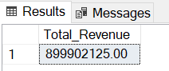

**Summary:** This query calculatesthe total amount of revenue generated from all sales transactions by summing the total sales column.

1. **Net Profit**

**SQL Query:**

SELECT SUM(Operating_Profit) AS Net_Profit

FROM Adidas_Sales_Data

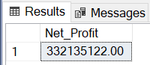

**Summary:** This sums up the operating profit column.

1. **Total Order**

**SQL Query:**

SELECT COUNT(*) AS Total_Orders

FROM Adidas_Sales_Data

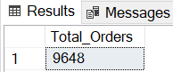

**Summary:** This query counts the total number of sales orders in the dataset. Each row is one order.

1. **Total Units Sold**

**SQL Query:**

SELECT SUM(Units_Sold) AS Total_Units_Sold

FROM Adidas_Sales_Data

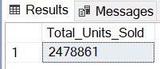

**Summary:** This query sums up all theindividual units sold across all orders.

1. **Average order value**

**SQL Query:**

SELECT (SUM(Total_Sales) / COUNT(*)) AS Average_Order_Value

FROM Adidas_Sales_Data

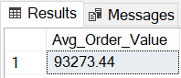

**Summary:** This query calculates how much revenueis earned on average per individual order by summing up the total sales column and dividing it by the total orders.

1. **Profit Margin %**

**SQL Query:**

SELECT (SUM(Operating_Profit) / SUM(Total_Sales) * 100) AS Profit_Margin

FROM Adidas_Sales_Data

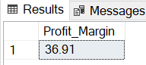

**Summary:** This query computes the percentage of sales revenue retained as profit after operational costs.

**Product Performance Analysis**

1. **Which products generated the most profit and revenue?**

This question helps identify the most financially valuable product.

**SQL Query**:

Total Revenue and Net Profit by Products

SELECT

Product,

SUM(Total_Sales) AS Total_Revenue,

SUM(Operating_Profit) AS Net_Profit

FROM Adidas_Sales_Data

GROUP BY Product

ORDER BY Net_Profit DESC

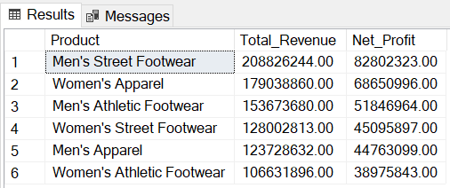

**Summary:** The SQL query above:

* Aggregates the total sales for each Product.
* Aggregates the Operating Profit for each Product
* Groups result by Product.
* Sorts the list in descending order of total profit, showing top-earning products at the top.

**Insight**

* Men’s Street Footwear was the highest performing product financially contributing a total of $208,826,244 in revenue and $82,802,323 in profit.
* Women’s Athletic Footwear generated minimal profit ($38,975,843)– it’s either overpriced or underperforming. It needs to be looked into.

**Possible Actions**

* Prioritize stocking and distribution of Men’s Street Footwear.
* Rethink pricing of Women’s Athletic Footwear, Men’s Apparel, and Women’s Street Footwear.
* Promote Men’s Street Footwear and Women’s Apparel more aggressively.

**Recommended Filters**

* **Region/State/City –** To see where profitable products perform best.
* **Year/Month –** To understand profitability trend overtime.
* **Retailer –** To evaluate retailer-specific product profitability.
* **Sales Method –** To check if certain channels contribute more to profit.

1. **How many units of product** **was sold each month?**

This question helps track product demand trends overtime and spot seasonal patterns or changes in consumer behaviour.

**SQL Query:**

Total Units Sold by Month and Product

SELECT

FORMAT(Invoice_Date, 'MMM') AS Month,

Product,

SUM(Units_Sold) AS Total_Units_Sold

FROM Adidas_Sales_Data

GROUP BY

Product,

FORMAT(Invoice_Date, 'MMM')

ORDER BY

FORMAT(Invoice_Date, 'MMM'),

Product

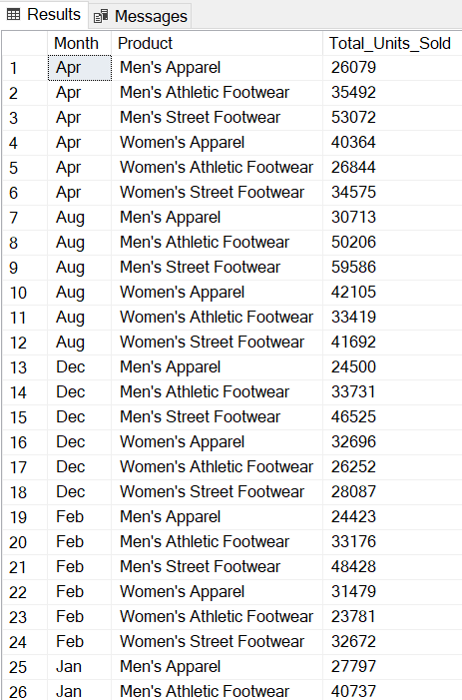

**Summary:** This SQL query:

* Extracts month from the Invoice Date using - FORMAT(Invoice_Date, 'MMM').
* Groups the data by Month and Product.
* Sums the Units Sold for each month.
* Orders the result chronologically by month, then by product.

**Insight:**

* Men’s Street footwear had the highest units sold across all months compared to other products. The most units were sold in August (59,586) and the least in November (41,025).
* Men’s Apparel and Women’s Athletic Footwear had the least amount of unit sold overall, with June being the worst month for both products.

**Possible Actions**

* There were more orders in August, therefore more products should be stocked during this time of the year*.*
* Products like Men’s Apparel and Women’s Athletic Footwear needs to be reviewed as they consistently performed poorly.
* Promotions should be scheduled for the last quarter of the year as fewer units were sold across all products at this time of the year.
* Increase themanufacturing of the product, Men’s Street Footwear, as it was constantly in high demand.

**Recommended Filters**

* **Year –** To compare one year at a time.
* **Region/State/City –** To localize demand patterns.
* **Retailer –** To see which retailers drive most of the unit sales.
* **Sales Method –** To check if online, in-store or outlet sales affect unit volume.

1. **What is the sales contribution (%) of each product? Margin Analysis**

This shows how much revenue each product makes compared to all the products combined.

**SQL Query:**

Sales Contribution % by Product

SELECT

(SUM(Total_Sales) * 100.0 / (SELECT SUM(Total_Sales) FROM Adidas_Sales_Data)) AS Sales_Pecentage

FROM Adidas_Sales_Data

GROUP BY Product

ORDER BY SUM(Total_Sales) * 100.0 / (SELECT SUM(Total_Sales) FROM Adidas_Sales_Data)) DESC

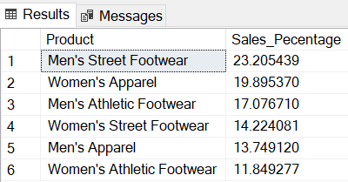

**Summary:** This SQL query:

* Computes each product’s percentage of total sales by multiplying each product’s total sales by 100.0 and dividing it by (SUM(Total_Sales)) using a subquery.
* Groups the data by Product.
* Sorts the result in descending order based on percentage contribution.

**Insight:**

* Men’s Street Footwear is the only product that contributes above 20% of total sales with a sales percentage of 23.2%, making it the best performing product.
* Women’s Athletic Footwear contributes 11.8%.

**Possible Actions**

* Pair high-selling products with underperforming ones to help boost their purchase.
* Focus promotional efforts on and Men’s Athletic Footwear.
* Evaluate if Men’s Apparel and Women’s Athletic Footwear are priced too high/low for their value.

**Recommended Filters**

* **Year/Month –** Understand how product contribution changes overtime.
* **Region/State/City –** To see if top contributors Men’s Street Footwear, Women’s Apparel differ by location.
* **Retailer –** To check which retailers sell the most of each product.

1. **What is the profit-to-sales ratio for each product? Margin Analysis**

This helps determine how profitable each product is compared to its total sales.

**SQL Query:**

Profit Margin % by Product

SELECT

Product,

ROUND(SUM(Operating_Profit) / SUM(Total_Sales) * 100, 2) AS Profit_Margin

FROM Adidas_Sales_Data

GROUP BY Product

ORDER BY Profit_Margin DESC

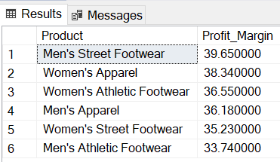

**Summary:** This SQL query:

* Groups the dataset by Product
* Calculates the Profit Margin using the formula - (Total Profit / Total Sales) * 100. It uses SUM(Operating_Profit) and SUM(Total_Sales) for each product.
* Rounds the result to 2 decimal places.
* Orders the product by highest to lowest profit margin.

**Insight**

* Men’s street footwear has the highest profit margin at 39.65%
* Women’s Athletic Footwear, although contributing the least amount in revenue, brought in a profit of 36.55%.

**Possible Actions**

* Increase prices on Men’s Athletic Footwear and Women’s Street Footwear, since they have a low-margin but high-demand.
* Prioritize marketing efforts on Men’s Street Footwear and Women’s Apparel, seeing that they have a higher margin. This will aid better return.
* Investigate high-cost drivers in low-margin products.

**Recommended Filters**

* **Year/Month** – To compare how margins evolve over time.
* **Region/State/City** – To check if profit margins vary across locations.
* **Retailer** – To identify which retailers generate higher-margin sales.

**Regional/Market Sales Analysis**

1. **Which region generated the highest and lowest revenue and total profit?**

This helps evaluate regional performance based on absolute profitability.

**SQL Query:**

Total Revenue and Net Profit by Region

SELECT

Region,

SUM(Total_Sales) AS Total_Revenue,

SUM(Operating_Profit) As Profit

FROM Adidas_Sales_Data

GROUP BY Region

ORDER BY Profit DESC

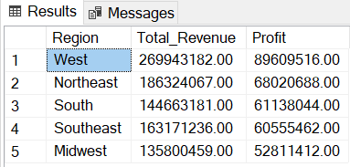

**Summary:** This query:

* Groups the dataset by each Region.
* Calculates the total revenue per region using SUM(Total_Sales).
* Calculates total operating profit per region using SUM(Operating_Profit).
* Sorts the result in descending order, showing the most profitable regions first.

**Insight**

* The West is the best performing region generating a total of $269.94M in revenue and $89.61M in profit while the Midwest is the least profitable with a revenue of ($135.80M) and a profit of ($52.81M).

**Possible Actions**

* Allocate more resources (e.g., sales teams, inventory) to the West.
* Tailor strategies to boost profit in underperforming areas like the Midwest.
* Investigate why the Midwest have low profits.

**Recommended Filters**

* **Year/Month –** To analyze how regional profit shifts over time.
* **State/City –** To drill down further into specific locations.
* **Product –** To see which products are driving profit in each region.
* **Retailer –** To identify which retailers perform best within each region.

1. **Which region has the highest average order size (sales per order)?**

This question helps assess customer purchase behavior and regional buying power.

**SQL Query:**

Average Order Size by Region

SELECT Region,

AVG(Total_Sales) AS Avg_Order_Size

FROM Adidas_Sales_Data

GROUP BY Region

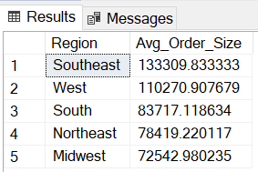

**Summary:** This query:

* Groups the dataset by Region.
* Calculates the average value of an order using AVG(Total_Sales) for each region.
* Returns a table of regions with their corresponding average order values.

**Insight**

* The Southeast ($133.31K) had the highest order size, despite ranking fourth in total profit.
* The West ($110.27K) had the second highest order size, but had the highest profit.
* The Northeast ($78.42K) and Midwest ($72.5K) had the lowest average order.

**Possible Actions**

* Push premium products ads in the southeast and west where average order sizes are higher
* Store more premium items in the southeast and west.
* Customize pricing offers by region.

**Recommended Filters**

* **Year/Month –** To observe how average order sizes change over time.
* **Product –** To see which products contribute to larger orders in each region.
* **Retailer –** To determine if specific retailers drive higher order values regionally.
* **Sales Method –** To explore whether online or offline orders impact regional averages.
* **State/City –** Drill down for more localized trends within each region.

1. **Which states generate the most and least sales and profit, and what is their profit margin?**

This question evaluates state-level performance across key financial metrics: sales, profit, and efficiency (margin).

**SQL Query:**

Total Revenue, Profit and Margin by State

SELECT State,

SUM(Total_Sales) AS Total_Revenue,

SUM(Operating_Profit) AS Net_Profit,

ROUND(SUM(Operating_Profit) / SUM(Total_Sales) * 100, 2) AS Profit_Margin

FROM Adidas_Sales_Data

GROUP BY State

ORDER BY Profit_Margin DESC

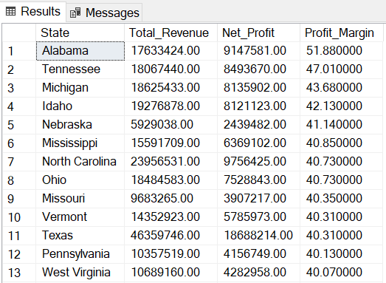

**Summary:** This query:

* Groups data by State.
* Calculates the total sales using SUM(Total_Sales).
* Calculates the total profit, SUM(Operating_Profit).
* Calculates the profit margin and rounds the decimal to 2 places.
* Sorts the result by profit margin in descending order to show the most efficient states first.

**Insight**

* The top 5 states with the highest profit margin have really low sales volume.
* New York generates the highest total sales, but Alabama has the highest profit margin.
* Nebraska has the lowest sales volume and profit, but has the fifth highest profit margin.

**Possible Actions**

* Focus on improving margin in high-sales, low-margin states.
* Invest more in high-profit-margin states to maximize ROI.
* Boost awareness or promos in low-sales, high-margin states.

**Recommended Filters**

* **Year/Month –** See if performance is consistent over time.
* **Product –** Understand which items drive sales/margin by state.
* **Retailer –** View profit performance of retailers within each state.

1. **What is the average price per unit of each region?**

This question uncovers how product pricing varies by region, which may be due to demand, product mix, or strategic pricing decisions.

**SQL Query:**

Avg Price per Unit by Region

SELECT Region,

AVG(Price_per_Unit) AS Avg_Price_per_unit

FROM Adidas_Sales_Data

GROUP BY Region

ORDER BY Avg_Price_per_unit

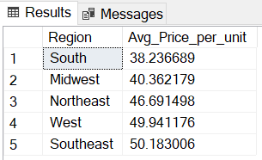

**Summary:** This SQL query:

* Groups the data by Region.
* Calculates the average unit price using AVG(Price_per_Unit).
* Orders the result by Avg_Price_per_unit (ascending by default) to compare regional price levels.

**Insight**

* Southeast ($50.18) has the highest average price per unit, which may be linked to higher demand for premium products.
* South ($38.23) shows the lowest average unit price.

**Possible Actions**

* Focus sales efforts on upselling in the southern region.
* Promote higher-margin or premium products in the south and midwest regions.
* Align marketing campaigns to reflect regional customer preferences.

**Recommended Filters**

* **Year/Month –** Analyze how average prices evolve over time in each region.
* **Product –** See which product groups contribute to price differences.
* **Retailer –** Investigate whether pricing varies across retail partners in different regions.
* **State –** Drill down further to more granular pricing patterns within regions.

**Retailer Analysis**

1. **Which retailer has the highest total sales and profit?**

This question helps assess retailer performance, showing which partners are most profitable and generate the highest sales.

**SQL Query:**

Total Revenue and Net Profit by Retailer

SELECT

Retailer,

SUM(Total_Sales) AS Total_Revenue,

SUM(Operating_Profit) AS Net_Profit

FROM Adidas_Sales_Data

GROUP BY Retailer

ORDER BY Net_Profit DESC

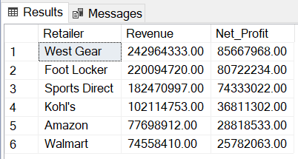

**Summary:** This SQL query:

* Groups data by the Retailer column.
* Calculates total sales and total profit for each retailer using SUM(Total_Sales) and SUM(Operating_Profit).
* Orders the result by Profit in descending order to highlight the most profitable retailers.

**Insights**

* Westgear is the best performing retailer, generating the highest amount in both sales and profit. Foot Locker is the second best.
* Walmart and Amazon both had the lowest sales and profit

**Possible Actions**

* Prioritize Westgear and Foot Locker for exclusive releases or bulk discounts.
* Investigate Walmart and Amazon for cost issues or pricing inefficiencies.
* Direct campaigns toward top-performing retail partners.

**Recommended Filters**

* **Region/State–** Understand retailer performance in different geographies.
* **Year/Month –** Track retailer performance over time.

1. **What is the order frequency of each retailer?**

This helps identify which retailers place the highest number of orders, regardless of volume or value.

**SQL Query:**

Total Orders per Retailer

SELECT Retailer,

COUNT(*) AS Total_Orders

FROM Adidas_Sales_Data

GROUP BY Retailer

ORDER BY Total_Orders DESC

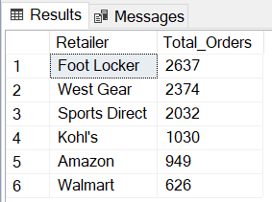

**Summary:** This query:

* Groups the dataset by Retailer.
* Uses COUNT(*) to determine the total number of orders per retailer.
* Orders the result in descending order to surface most frequent ordering retailers.

**Insight**

* Foot Locker had the highest orders with a total of 2637 orders. West Gear followed closely with a total of 2374 orders.
* Walmart had the lowest order frequency with a total of 626 orders.

**Possible Actions**

* Automated reorder systems should be made available for Foot Locker and Westgear.
* Tailor logistics and supply chain to meet frequent demand.

**Recommended Filters**

* **Year/Month**
* **Region/State**

1. **Which retailer has the highest average order size (sales per order)?**

This shows which retailers place high-value orders, regardless of how often they order.

**SQL Query:**

Average Order Size by Retailer

SELECT Retailer,

Avg(Total_Sales) AS Avg_Order_Size

FROM Adidas_Sales_Data

GROUP BY Retailer

ORDER BY Avg_Order_Size DESC

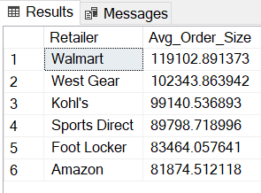

**Summary:** This query:

* Groups the dataset by Retailer.
* Calculates the average of Total_Sales for each retailer using AVG(Total_Sales).
* Orders the results from highest to lowest average order value.

**Insight**

* Walmart had the highest average order size totalling $119,10K.
* West Gear followed closely with an average order size of $102,34K.
* Amazon and Foot Locker had the lowest average order size, totalling $81,87K and $83,46K.

**Possible Actions**

* Align inventory and fulfillment strategies with order size behavior.
* Provide tiered pricing for large average orders.

**Recommended Filters**

* **Year/Month**
* **Region/State**
* **Product**

1. **Which sales method performs best in terms of total sales, profit, and profit margin?**

This question aims to assess the effectiveness and profitability of each channel used to sell Adidas products — whether online, in-store, or outlet.

**SQL Query:**

Sales Method Performance

SELECT Sales_Method,

SUM(Operating_Profit) As Net_Profit,

ROUND(SUM(Operating_Profit) / SUM(Total_Sales) * 100, 2) AS Profit_Margin

FROM Adidas_Sales_Data

GROUP BY Sales_Method

ORDER BY Net_Profit

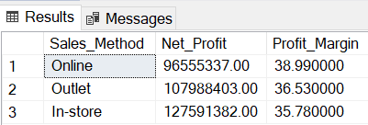

**Summary:** This query:

* Groups the Adidas sales data by each Sales_Method.
* Calculates total profit (SUM(Operating_Profit)).
* Calculates the profit margin (Operating_Profit ÷ Total_Sales × 100).
* Rounds the profit to 2 decimal places.
* Sorts the result by the total profit, helping us see which method contributes most profitably.

**Insight**

* In-Store sales method generated the highest revenue and profit but had the lowest profit margin at 35.78%.
* Online sales method had the highest profit margin at 38.99%, but had the lowest total sales and profit.

**Possible Actions**

* Reevaluate pricing for in-store sales method.
* Focus should be given to online sales methods rather than just in-store and outlet.

**Recommended Filters**

* Retailer
* Region/State
* Year/Month

1. **How does profit fluctuate over time on a monthly basis?**

This helps identify seasonal patterns, periods of growth or decline, and months with profit inconsistencies.

**SQL Query:**

Net Profit by Month

SELECT FORMAT(Invoice_Date, 'MMM') AS Month,

SUM(Operating_Profit) AS Net_Profit

FROM Adidas_Sales_Data

GROUP BY FORMAT(Invoice_Date, 'MMM')

ORDER BY FORMAT(Invoice_Date, 'MMM'),

Net_Profit

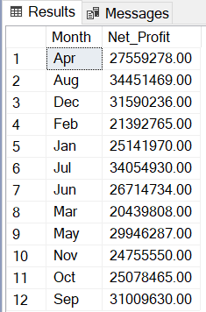

**Summary:** This query:

* Groups the data by month (FORMAT(Invoice_Date, 'yyyy-MM')).
* Calculates the profit for each month (SUM(Operating_Profit)).
* Sorts the result chronologically by month, then by profit to ensure accurate trend analysis.

**Insight**

* The most profit was made in August ($34.45M).
* There’s a significant dip in profit between September and November. This needs to be investigated.
* March ($20.43M) had the least profit.

**Possible Actions**

* Anticipate stock needs based on past demand peaks***.***
* Schedule and optimize marketing campaigns between September and November.
* Align workforce scheduling with expected busy/slow months.

**Recommended Filters**

* **Product**
* **Year**